### ***Wind Powered Tops***

### 

Ryan Rhodes (rbr673)

Dahlia Lopez (dtl583)

Christopher Yoon (jy7338)

Erick Jones (ecj333)

### 

Additive Manufacturing

Spring 2020

### Table of Contents

Wind Powered Tops **1**

Table of Contents **2**

Introduction **3**

Customer Needs **3**

Specification Sheet **4**

Economic Justification for SLS **6**

Concept Generation **7**

Concept Selection/CAD/Detailed Design Process **10**

Economic Analysis **14**

Product Evaluation - Aerodynamics **15**

Survey Results **18**

Recommendations **19**

Conclusions **19**

Challenges and Lessons Learned **20**

Appendix A: Gantt Chart **21**

Appendix B: Customer Needs Survey Form **22**

Appendix C: Aerodynamic Analysis **25**

References **26**

### 

### 

### 

### Introduction

Tops are one of the oldest archaeological identified toys and have been used as toys, for gambling, and even to tell prophecy. Newer top designs include beyblades, 3D-printed designs, and air-powered tops. While the concept behind tops is simple, twist and spin, the idea continues to live on. Perhaps ForeverSpin says it best:

*“WHY A SPINNING TOP? THERE WILL BE SOMETHING IN IT FOR YOU FOREVER.*

*Perhaps you need a little boost in creativity or focus, or you need to de-stress a bit. Maybe you're in search of a gift that lasts forever or want to compare weight and touch different metals. Or you just like a bit of competition or you love minimalistic art. Engineers, kids, designers, collectors... No matter how old, how wise and how smart you become there will be something in it for you Forever.”*

Our objective was to design a high quality collectible spinning top that shows off the capabilities of SLS additive manufacturing. Our top must be novel, have a performance similar to other high end tops, and meet customer demands. We focused on the novelty of the top because with SLS we could make intricate and complicated designs that had never been seen before. After gathering data on the market, customer demands, and on our competition’s design specifications, we generated many concepts.

Once we decided which concepts to adopt, we designed an air-powered modular top system that paired a universal bottom with wind turbine blades in the center with two UT-themed interchangeable top designs, one of the UT tower and the other of the UT seal. We tested the aerodynamics of the blades to ensure that the top would spin as designed and modified the blades accordingly. Finally, we calculated that it would cost between $20 and $30 to build each top.

### Customer Needs

Our team decided to aim our product towards collectors. Our ideal customer is an avid collector of spinning tops or someone who appreciates a high quality desk toy. With the fidget spinner craze that hit the markets a few years ago, the market for high quality spinning tops also began to grow. We are basing our customer needs off those of someone who may be looking to purchase a high quality, novel top.

Our first focus of customer needs is the appeal of the product. We will design a spinning top that is attractive to the customer and something that people will be proud to show off. It will have an aesthetically pleasing design that will grab anyone’s interest. It will also show off the capabilities of additive manufacturing, and more specifically SLS, and be a spinning top that is truly unique.

The next main category of customer needs is performance. Our top must be able to perform well, otherwise the appeal of the top will go down. Spin time is one of the most important performance metrics. The top must be able to spin for a considerable length of time without falling over. The top must also be able to spin at high enough rotational velocity to achieve this considerable spin time. The top must be durable so as to not break if it were to collide with another surface while spinning or if it were to fall from a height of a desk or a table.

The last category of customer needs is the cost of the top. Current high quality spinning tops on the market currently range from $20 to over $200. We aim to have the cost of our somewhere between that. We aim to have our cost be affordable for the customer based on the detail and size of the spinning top. Below is a table of our customer needs, with each need given a weight of importance with 5 being most important and 1 being least important.

Table 1: Customer Needs Analysis

|  |  |  |  |
| --- | --- | --- | --- |
| **Customer Needs** | | | |
| **Appeal** | | | **WT** |
| Aesthetically Pleasing | | | 5 |
| Novel/Unique design | | | 4 |
| AM exclusive construction | | | 4 |
| **Performance** | | |  |
| Long Spin Time | | | 3 |
| High Spin Speed | | | 4 |
| High Durability | | | 5 |
| **Cost** | | |  |
| Affordable cost compared to similar high-end tops | | | 4 |

### Specification Sheet

Based on the customer needs analysis, our team generated a requirements list for our potential product.

Table 2: Specification Sheet for Wind Powered Tops

|  |  |  |  |
| --- | --- | --- | --- |
| **Requirements List** | | | |
| **Requirements** | | | **Specifics (Demand/Wish)** |
| Aesthetic Appeal and Customization | | | N/A (D) |
| Long Spin Time | | | > 30s (W), >10s (D) |
| High Spin Speed | | | > 5000 rpm (W), >3600 rpm (D) |
| High Durability | | | > 2000 launches (W), >500 (D) |
| Low Cost (compared to high-end spinning tops) | | | < $300 (D), <$100 (W) |
| Portable Size | | | < 3”x3”x5” (D), 3”x3”x3” (W) |
| Portable Weight | | | < 6 oz (D), < 3oz (W) |
| Low Number of Parts (Ease of Assembly) | | | < 3 parts (W) |

As mentioned in the customer needs analysis, aesthetic appeal is an important factor to consider in the product design phase. The geometry of the top should also take advantage of the unique capabilities offered by AM. Quantifying attractiveness in numbers is difficult, since it is inherently subjective. One idea would be simply surveying potential customers. For example, our team can ask a group of people to give 0 to 5 points based on aesthetic appeal. Our goal could be to have an average of more than 3.5 out of 5.

Long spin time, high spin speed, and high durability is important. We would want the top to spin for at least 10 seconds, ideally over 30 seconds like we expect from regular tops. AFor spin speed, a typical rpm for plastic Beyblades launched with a launcher is around 5000 RPM. Our goal is to reach this baseline, but for hand-spun tops we could lower the expectation. The minimum spin speed (in revs per second) for a typical top to be stable is roughly equal to √g/a where g=9.81m/s2 and a is the radius of the top. (<http://www2.eng.cam.ac.uk/~hemh1/gyroscopes/spinningtop.htm>) For our top with expected radius of 4-5cm, the minimum spin speed is around 62-78 rev/s, or 3600-4800 RPM. Therefore, we put 3600 rpm as the minimum requirement for spin speed. High durability is also important. The top’s important features should be placed at locations that don’t come into physical contact with the environment. The product should last more than 500 typical launch cycles at minimum, considering that Nylon isn’t best at handling high stresses.

Portable size and weight is also important. Ideally it would fit inside a pocket (3”x3”x3”), but for special tops that show off intricate geometry, we gave a more generous set of dimensions. For weight, a Beyblade with a launcher weighs around 2-3oz, so we expect to be around that range.

Benefit of AM is that we can consolidate parts that would otherwise need to be assembled in traditional manufacturing. We aimed to have the total number of parts to be less than 3.

### 

### Economic Justification for SLS

Intricately designed spinning tops cost around $20 retail. They are generally small (can fit in the palm of your hand) and as a result use very little material. Precision machined metal tops like those made by ForeverSpin are between $35 and $100. More intricate and unique metal tops like those made by Billet Spin can retail as high as $345. They are also small but are made of metal which is more expensive. Air powered tops like the Zephr retail at around $100. They are much bigger than the intricate tops but still relatively small overall and use just a little material.

To be economically competitive we must be able to print multiple designs at an average cost somewhere between $20 - $350. Obviously this will be dependent on the material and type of top but these are the ranges. The build envelope for the SLS machine that we will be using is around 37x32x45cm (53,280cm^3), and the buildable volume is 32x27x40cm (34,560cm^3). Each team will aim for less than third of that volume. Nylon-12 powder is around $45/kg from 3rd party sellers, with powder density around 0.5 g/cm^3. At $45/kg, the cost to fill the chamber is around $1600 if using 100% virgin powder, including ⅓ extra for overflow. If only half of the powder is virgin powder, the price is around $800 to fill the entire chamber. So the material cost for ⅓ of the build envelope is at most around $540. If we set our build volume as 6”x6”x16” (15 x 15 x 40cm), and the top occupies around 3” x 3” x 3” in volume, we can produce 20 tops (4 tops per layer, 5 layers). This will give us the material cost of $27 per top as maximum. Variables such as the size of the top (it may be larger or smaller than given volume), labor cost, and machine operating cost may change the actual cost, but targeting under the $100 line certainly seems feasible.

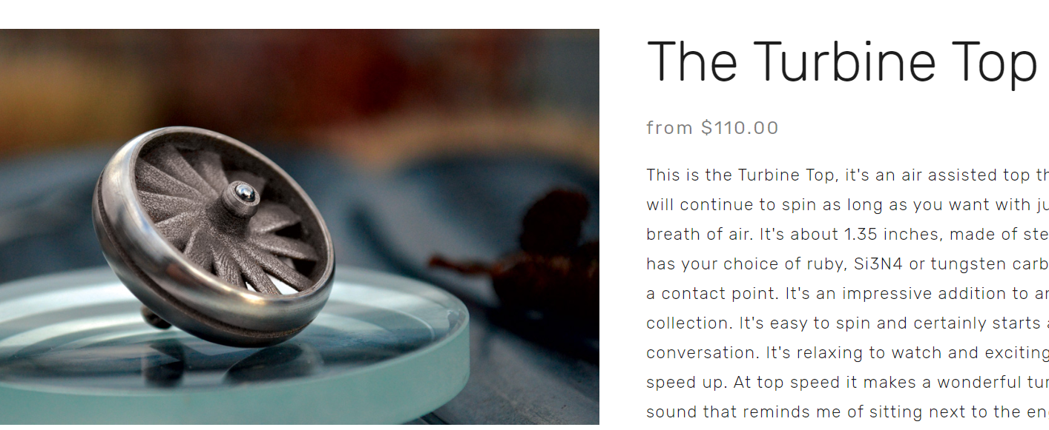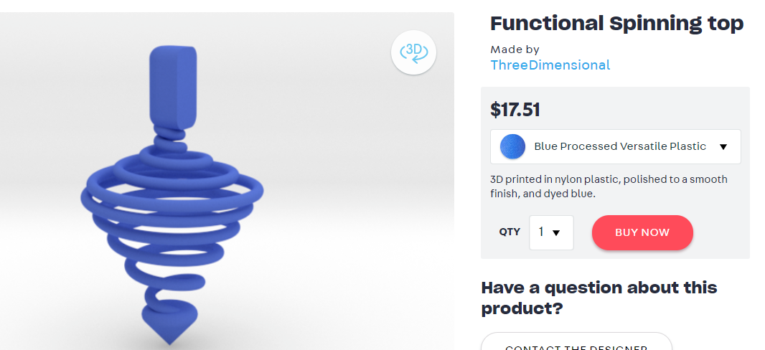

### 

Figure 1: Images and Prices of Different Types of tops on the Market

### Concept Generation

Following the creation of our problem statement, we took the first steps towards deciding on our design by having each member of the team draft up various conceptual designs individually and then come together to share them as a group. Each member of the team utilized a classic brainstorm method by jotting down and sketching various design ideas, with each concept seeking to take advantage of the benefits of SLS printing, including complex geometries, feature resolution, and strength of the part. Once everyone had each prepared a few concept ideas, we met as a group through Zoom and presented each idea, explaining the features and functions of each design. We then discussed the concepts together, and voted as a group for our top five design choices. These top five choices narrowed down our options to set us working towards a leading concept and possibly utilizing our favorite features within the top five choices into our final design. The five leading concept sketches are as shown below:

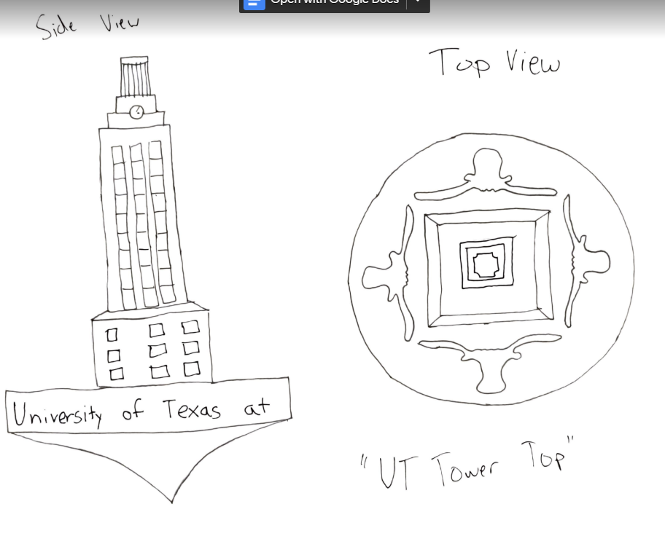

Figure 2: Concept Choice 1, the UT Tower

This design includes a small detailed model of the UT Tower as the handle of the top. The flared circular base has four longhorns at each base of the tower. These are seen from the top view of the top, and can be made to either cut into the base or extrude out of it.

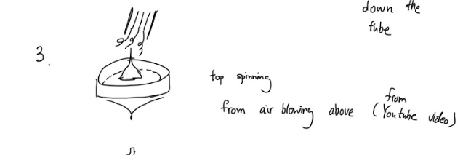

Figure 3: Concept Choice 2, an Air-Powered Top

This top design is unique because it is powered by air blown directly above the fan. This idea was inspired from a Youtube video (<https://youtu.be/D8nSKMdYse8>). The top of the fan is made up of turbine blades that cause the body to spin when air flows through. The top would be powered by air blown through the blades from down a tube or straw.

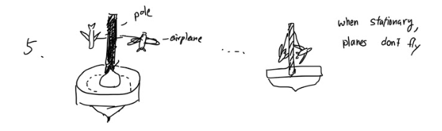

Figure 4: Concept Choice 3, A Spinning Airplane

This top design is a modified version of the air-powered top. The base is spun by blowing air on it. The top part contains two small airplanes hanging from a tall handle. The airplanes as well as attachment to the handle would be printed in one whole piece. When the top is spun, the planes will pull apart and fly as the body spins - much similar to the movement of a tether ball when struck. On a typical top, this design would be infeasible because the attachments would impact the stability of the top. But air-powered configuration can take advantage of constant air supply from blowing air, and would make this design possible.

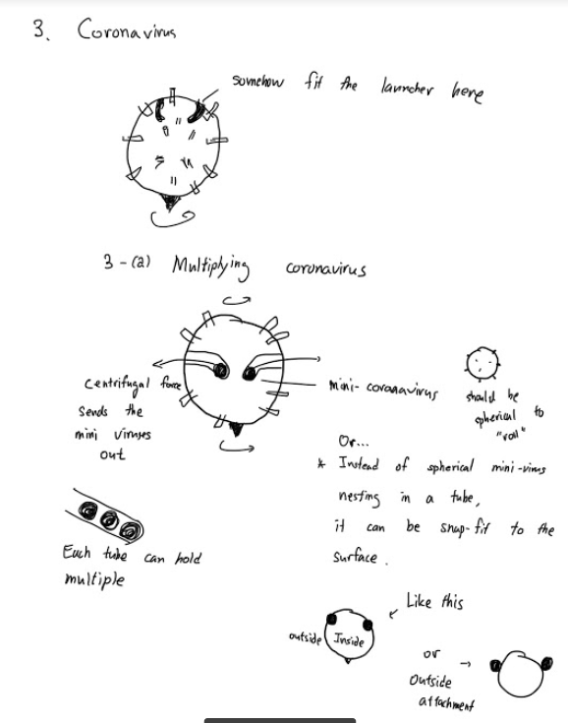

Figure 5: Concept Choice 4, the Coronavirus

This top is designed to be launched into motion using a launching mechanism similar to that of the popular Beyblade tops sold by Hasbro. This top is meant to be shaped like a single SARS-CoV-2 virus protein, commonly known as COVID-19. This design would have small chambers inside that hold small, sphere-shaped bearings, which would fly out of the top when spun, mimicking the “spread” of the virus.

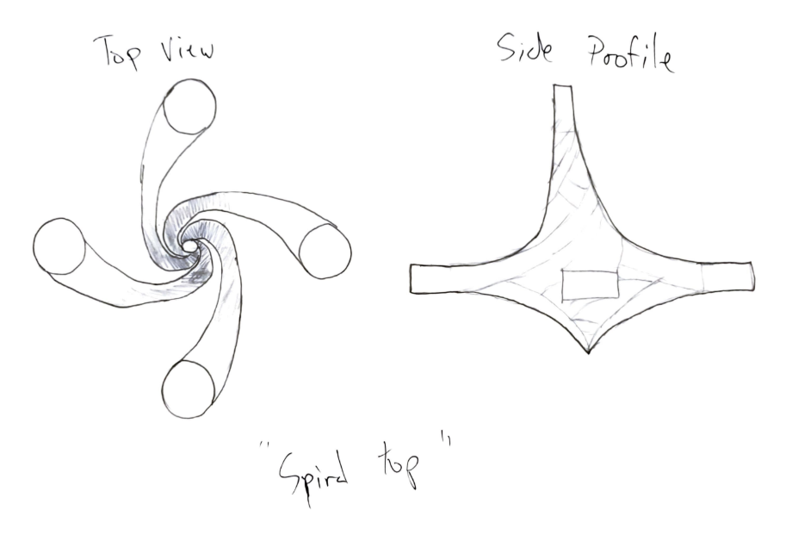

Figure 6: Concept Choice 5, a Weighted Spiral

This final design has a unique geometry in which the body is made up of four rigid spiraling bars. The bars twist together to create the shape of the top and meet at the tip where the top balances and spins on.

### Concept Selection/CAD/Detailed Design Process

After concept generation, we decided to incorporate the top two ideas: UT Tower and Air Powered. We chose this because it offers a good balance of functionality and aesthetics. The first step was designing the air powered portion of the top since this is the root function of the top. We first started by experimenting with Fusion 360 and figuring out a good way to design an impeller like design. The first iteration of our top base design is seen below.

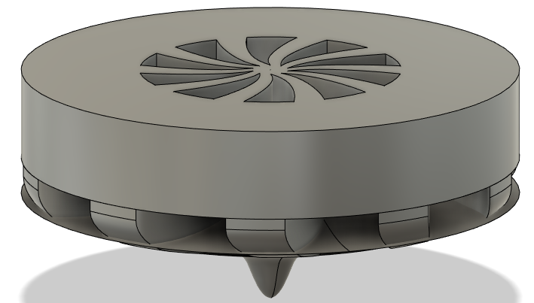

This was created by making a sketch of the geometry of a single “blade”, or in this case, the space between the blades. This was then rotated around using the pattern function and then cut through the solid body of the top. This cut channels into the top for the air to flow through and give the top angular momentum. The concept was there in this design but the execution was shoddy and needed improvement, so the team restarted and made a better design of this base. This new base can be seen below.

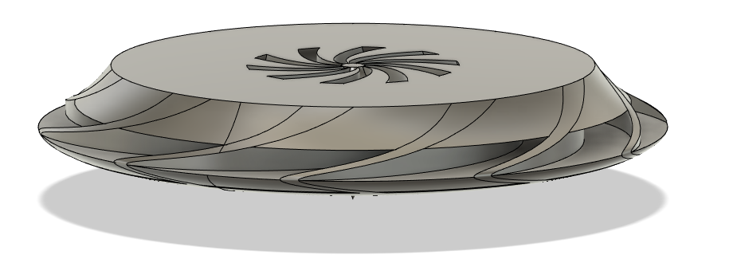

This design featured a much lower center of mass. This was implemented to give the top better stability while it was spinning. The airways are also much larger and more directed outward to give the top more rotational speed. We also implemented a sloping geometry from the center to the outer edges of the top to allow for easier directing of the airflow. However, after using an impeller design software to gain some insight on impeller geometry, we realized that we needed to make more changes. The final design for the base can be seen below.

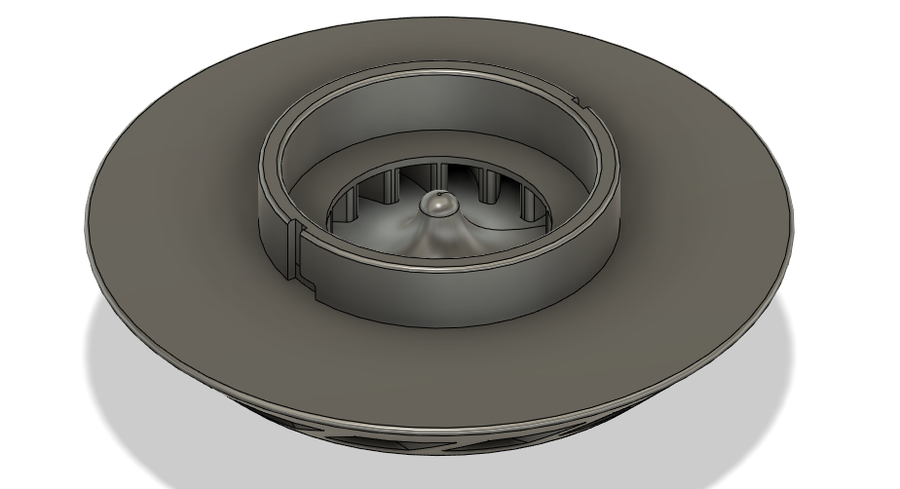

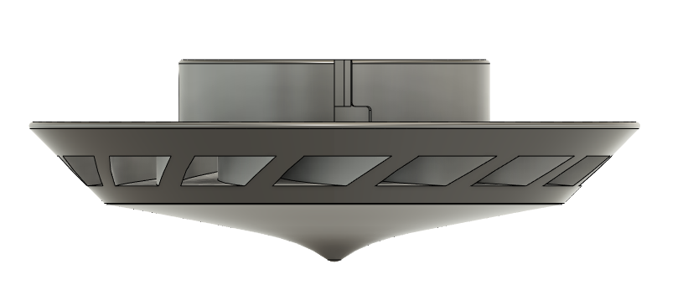

This final design implements all the knowledge we had learned from the first two iterations as well as the insight gained from the impeller software. It features better inlet and outlet angles to allow for higher rotational speeds. The outlets were also aimed more outward and downward to provide more stability. There were also more airways added so the force is more evenly distributed along the circumference of the top. The top portion was also opened more for easier inflow of air. Finally a mounting mechanism was added. In order to incorporate the “UT Tower” side of the top, we decided to make it modular, meaning that the base, with the wind powering mechanism, and the top, the aesthetic and novel part, would be separate components. We decided to use a simple slot-like locking mechanism. Tabs on the base of the top component would slide into the tracks on either side of the mount and the lock into place by twisting. This locking mechanism would be reinforced by the reaction forces experienced due to the top 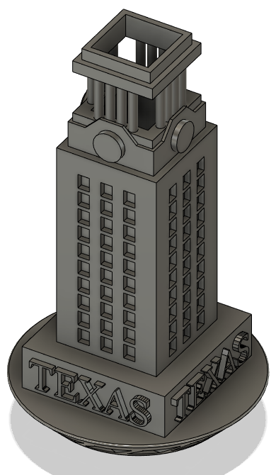spinning at high RPMs.

With the air powered base design solidified, we then moved on to designing the more aesthetic portion of the top, the UT Tower. This component is meant to be a scaled down representation of the beloved UT Tower that resides in the center part of campus. We wanted to capture its beauty while still allowing it to be a functional component of the spinning top. The tower features notable details from the original such as the windows, the clock face, and the column structure that sits on top. These recognizable features make this top unmistakable. The next step was figuring out how to mount it onto the base, while keeping the functionality of the air-powered spinning top. We added a cut-out on the underside of the tower that fits snuggly onto the center mounting portion of the base. There are two small protrusions on either side of this cut-out that slide into the grooves of the slot-like locking mechanism that keep the tower secure to the base. Finally, the center of the tower is completely hollow, allowing for air to easily travel through to spin the top.

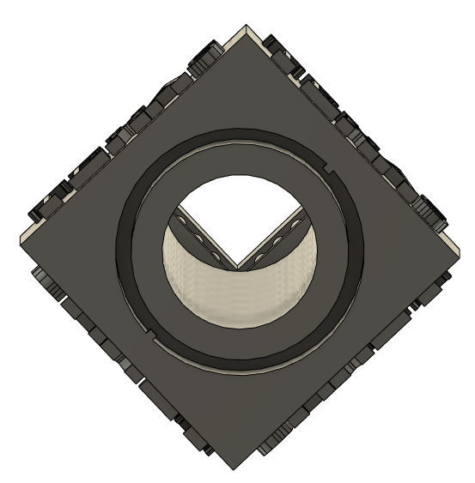

With the tower and base complete, our original idea was finished. However, we saw an opportunity arise with the modularity of our spinning top. With the easy mounting mechanism, our base could be used with a variety or interchangeable, customizable top components. The team decided to continue with the UT theme and create a top component that resembles the crest of the University of Texas at Austin. While the geometry is relatively simple, the idea showcases the possibilities of further customization of the top. As long as the top component is capable of mounting on to the base, the variations of custom tops could be limitless.

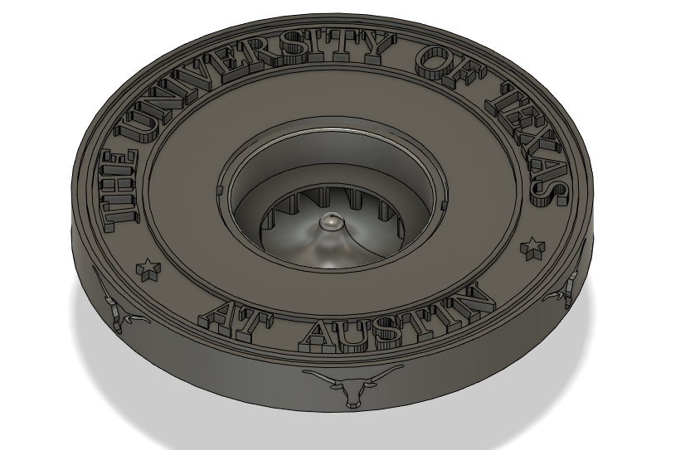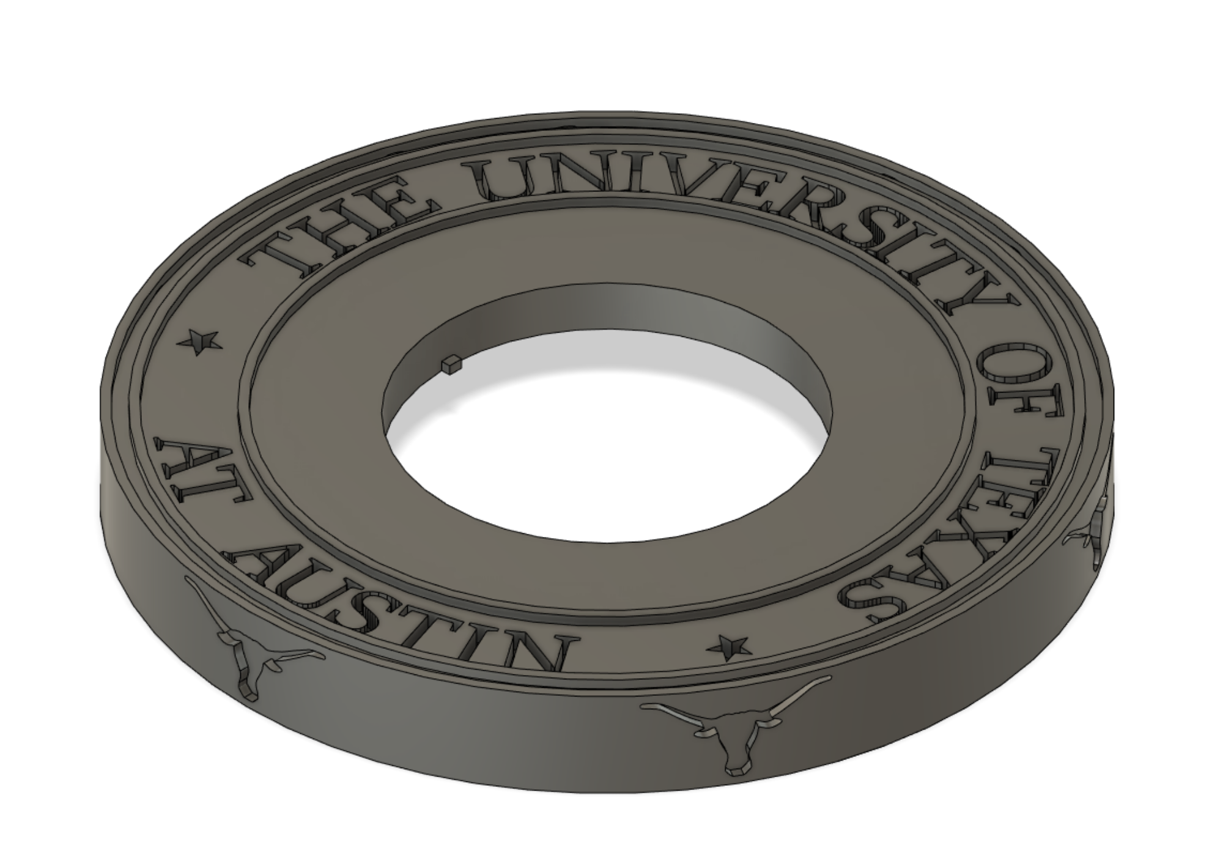

### Economic Analysis

One of the competitive advantages that our product has is that it occupies a small volume in SLS. So instead of choosing one ultimate design, our group was able to come up with several designs that could all be manufactured in ⅓ of the SLS build volume.

From lectures provided by Dr. Seepersad, the following information was provided.

Table 3: Cost to fill and build chamber in Nylon SLS

|  |  |
| --- | --- |
| Nylon-12 Price | $45/kg for virgin powder (from 3rd party) |
| Powder Density | 0.5g / cm^3 |
| Operational Cost | Similar to material cost |
| Total build volume | 0.37m x 0.32m x 0.45m (53,280cm^3) |
| Overflow | ⅓ of the volume |

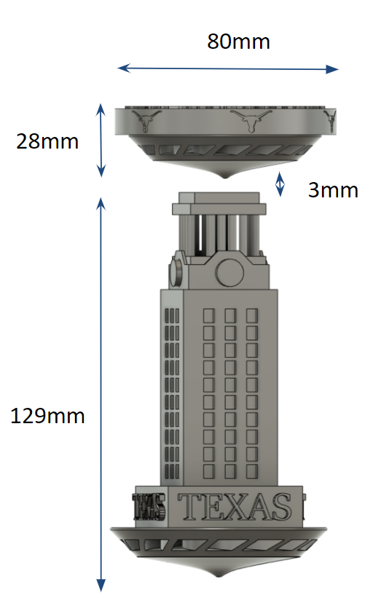

Figure 7: Build dimensions for two tops. The depth is the same as width (80mm), and 3mm gap between two parts are included.

Our total build volume is 80mm x 80mm x 160mm, or around 1024 cm^3. Note that this is only 2% of the total build volume (53,280cm^3). With this volume, we would be using around 512g of Nylon-12 powder. The price comes out to be $22 if using 100% virgin powder, or $11 if using 50% virgin powder. Assuming we use 50% virgin powder, after accounting for ⅓ overflow and assuming operating cost is roughly equal to material cost (~$15), the total cost for two tops comes out to be $29. Accounting for different sizes, the tower top would be $24 and the crest top would be around $5. This is well below the $100 mark as we expected.

### Product Evaluation - Aerodynamics

While the aesthetic requirement was largely dependent on customer survey results, we needed a way to evaluate the functionality of the top without testing it physically. For this, our team conducted a simplified 2 dimensional analysis, assessing the aerodynamics of the blade geometry that will provide spinning force. The diagram below shows the velocity triangle in the perspective of a moving blade.

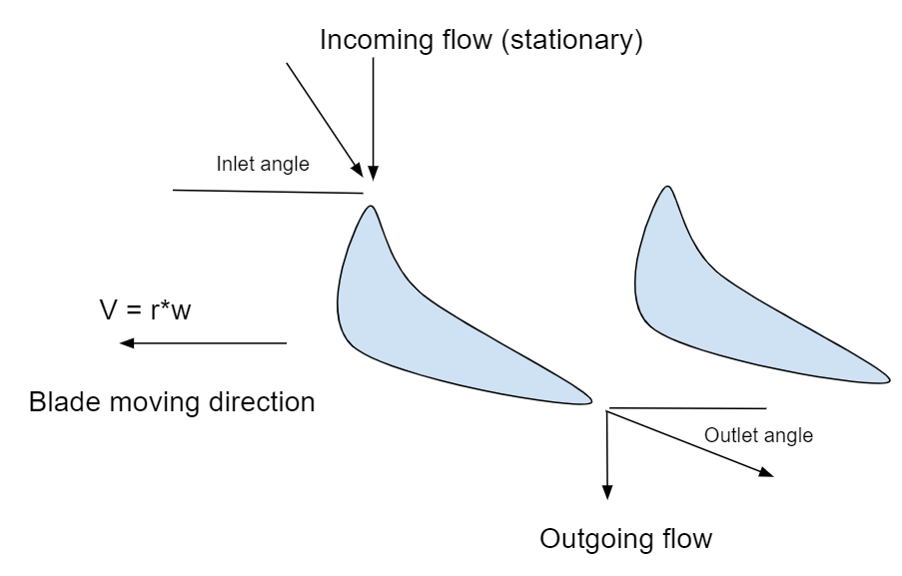

Figure 8: Velocity triangle of moving blade from top view, where V is the blade velocity, r is the radius from the center, and w is the angular velocity

In the diagram shown, our goal was to find appropriate inlet angle and outlet angle for the blade to achieve a specific target rpm. A spreadsheet was created that allowed variable user inputs, (<https://docs.google.com/spreadsheets/d/1LzFRLW5pDFwnHbtjJXq7VosLb4hO2LwIuaviyyzBXck/edit?usp=sharing>). The tables are provided in the link, but also shown below.

As seen in Table 4, we set a target rpm of 5400. Radii from the center to the inlet and outlet of the fan were already determined from the design. Therefore, the only input left was the incoming velocity. Finding the appropriate wind velocity that could be generated from human lungs were challenging. There were a lot of variables, such as gender, lung volume, and more importantly, the measurement method - such as blowing to a tube/spirometer, or blowing to blank space. We found a range from 10m/s - 50m/s. Considering that we planned to have a tower with a cylindrical hole in the center, velocity through a tube seemed to be the right way.

An aerodart design guide online had a target muzzle speed of about 48m/s. We chose to be more conservative and chose 35m/s as inlet velocity.

Table 4: Inlet and Outlet Angle Calculations

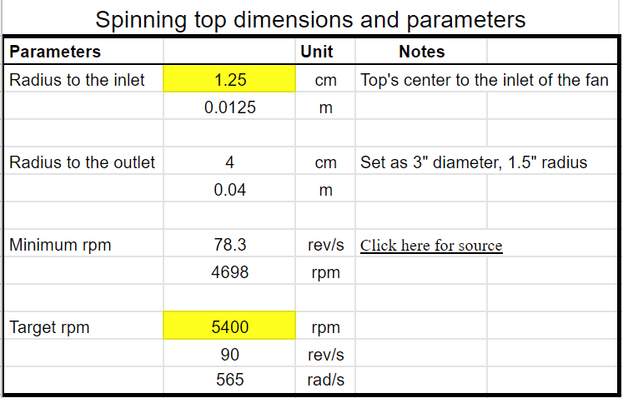

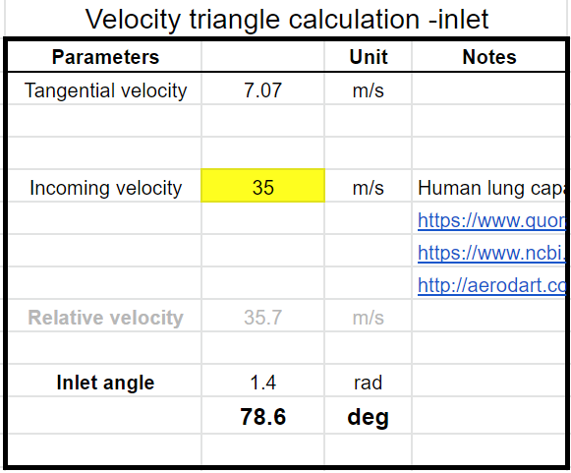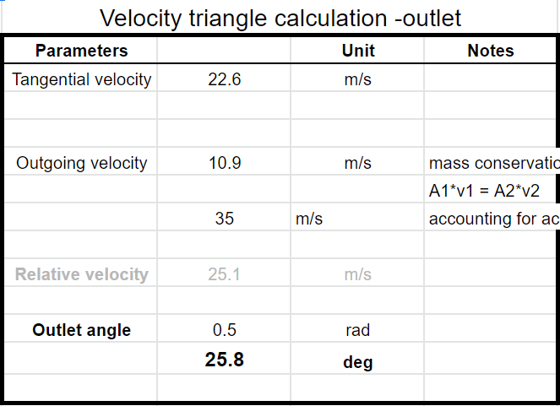

With these inputs, our calculations showed that we needed an inlet angle of 78.6 degrees and outlet angle of 25.8 degrees. We went back to the CAD design phase and adjusted the angle of the blades so that it met the criteria. It is interesting to note that these angles ensure that the maximum velocity that can be reached is the target angular velocity (5400rpm), given that incoming velocity is constant. A more detailed discussion of this calculation is presented in Appendix C.

### 

Figure 9: Inlet angle on both sides of the blade. Average angle is 78 degrees.

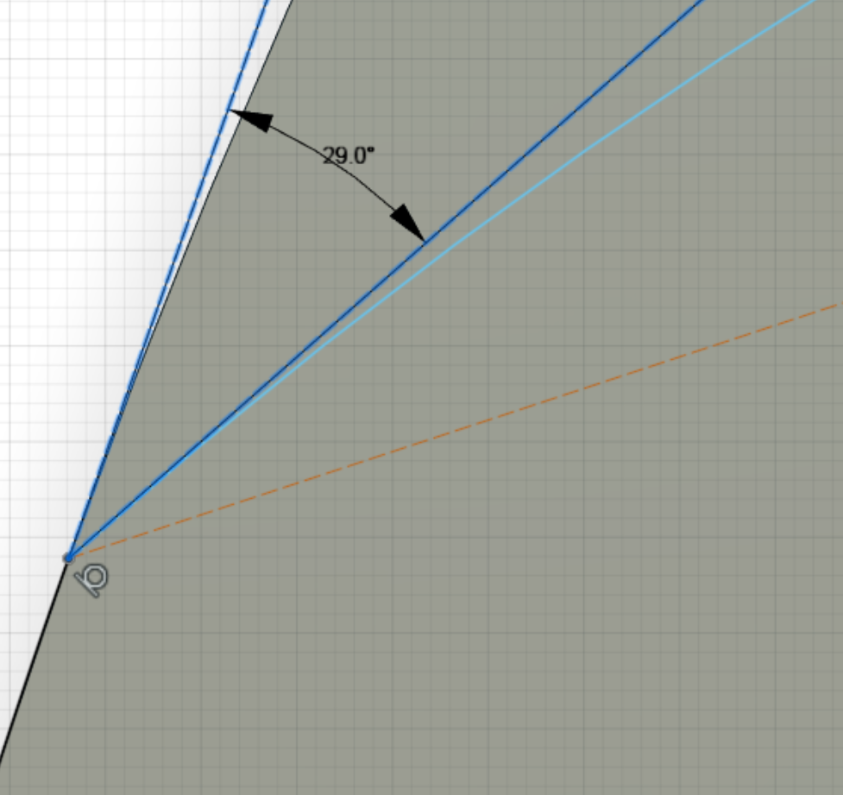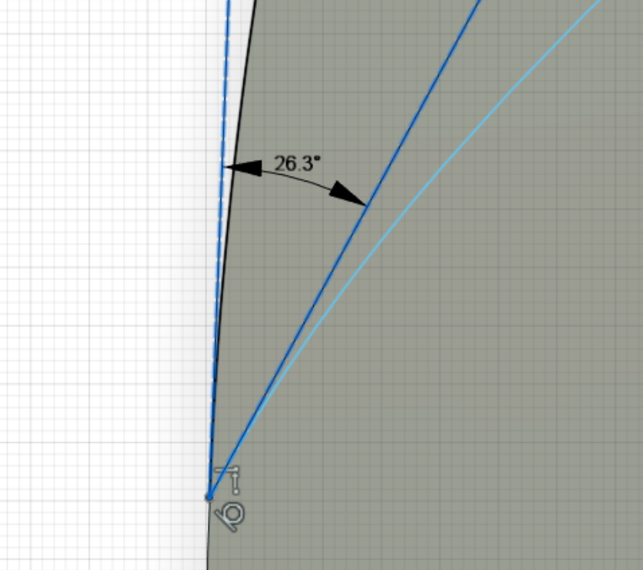

Figure 10: Outlet angle on both sides of the blade. Average angle is 27.7 degrees

### Survey Results

Although we identified a list of engineering specifications and customer needs for the top, it was important for us to conduct an analysis in order to see how our audience scored our design concepts. We developed a survey through Google Forms (see Appendix C) and sent it out to our undergraduate and graduate peers/classmates. This survey allowed us to receive feedback on our designs as we asked the surveyees to rate the interchangeable top components based on aesthetic appeal on a scale from 0 to 5.

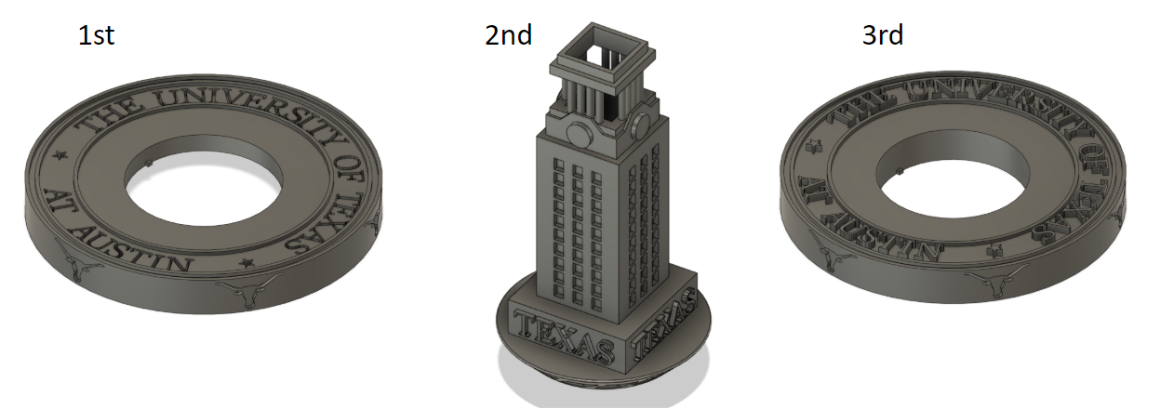

Figure 11: Customer survey results (36 responses)

The UT crest design with the embedded lettering received the highest score with an average aesthetic rating of 3.67 out of 5, followed by the UT tower with a score of 3.44 out of 5, with the extruded lettering crest design coming last with a score of 3.05 out of 5. Conducting this survey was beneficial for us to gain insight on the appeal of our design concepts, and to understand our target audience and their opinions on design aesthetics. After analyzing the survey data, we have a sense of what changes and updates could be made for this design in the future to make our product as attractive as possible for our consumers. For reference, a table of the full survey data can be found at the end of Appendix B.

### Recommendations

While 2D analysis was conducted to optimize blade inlet and outlet angles, it had its limits. It was not necessarily designed to minimize pressure loss or optimize airflow. Further improvement is possible by utilizing a blade designing software. ANSYS BladeGen is a software used to generate impeller designs. Impeller blades and the wind powered top blades have a lot of similarities, where it redirects the incoming flow in radial direction. Although the group attempted to import the blade from this software into the CAD model, there were some difficulties. First, the software was intended for real engineering uses, like designing centrifugal water pumps, so the user input parameters were based on realistic parameters. Modeling a high speed, 3” diameter impeller with airflow needed a lot more tweaking, and the group members did not have sufficient experience to tweak the settings correctly.

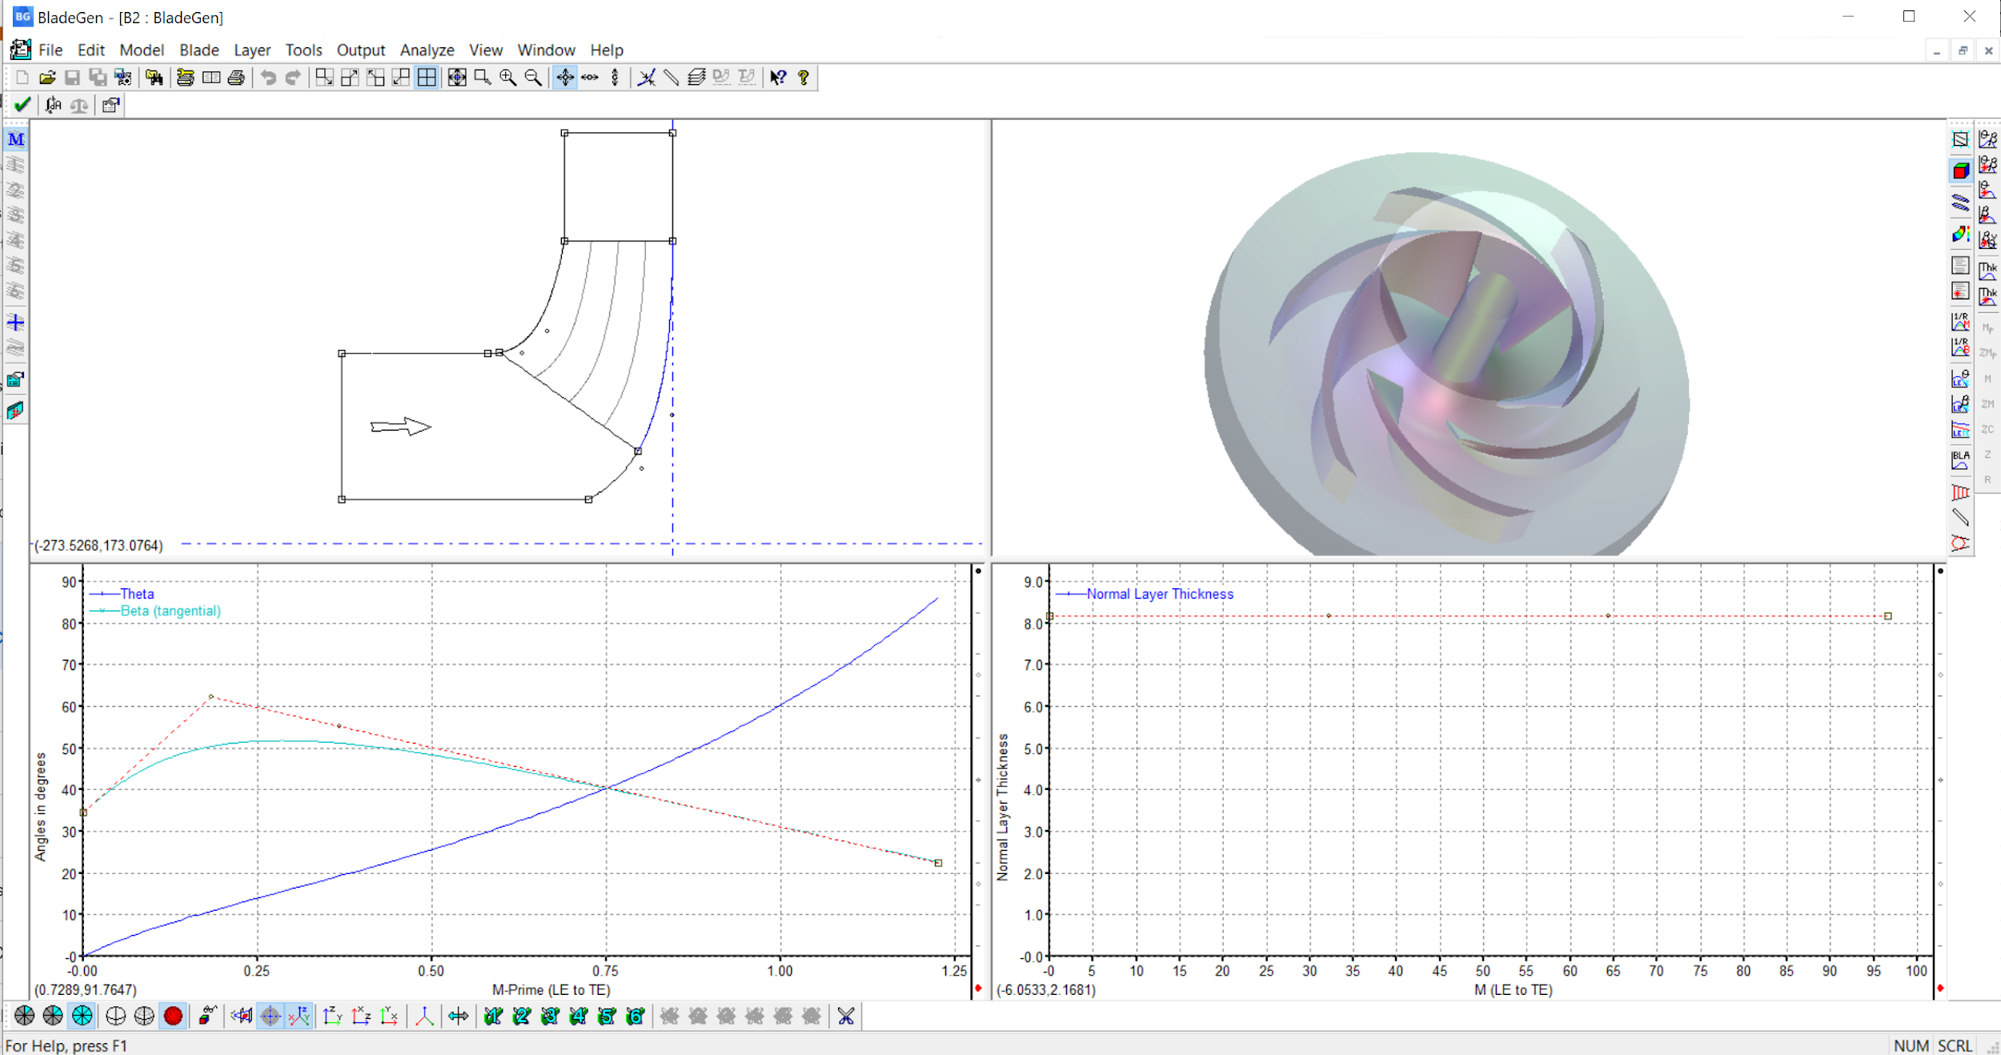

Figure 12: Screenshot of ANSYS Blade Gen software

### Conclusions

We designed a spinning top that is novel, aesthetically pleasing, durable, spins well, and whose unique fan assembly can only be made using SLS. Our design incorporates a modular top system that allows for interchangeable designs to be attached to the universal base. We designed two UT-themed attachable tops, one that is a replica of the UT model tower and the other that is a replica of the UT seal. The universal base has wind turbine blades in its center so that air can be blown through it to keep it spinning even with a large top installed. The end result, a unique spinning UT tower and a spinning UT seal both powered by air and that can only be fabricated using SLS.

According to our research, the market for tops ranges from cheap toys with cool designs to expensive over $300 collectors items made of polished metals. The data from our survey suggested customers desired an aesthetically pleasing top that was novel and spun well over all other criteria. And our review of the design specifications of other tops gave us parameters for which to judge our own top.

Using the market, customer, and design specification information we came up with numerous designs eventually narrowing down our choices to five designs. Then we took our top two designs, the UT tower and an air-powered top, and combined the concepts behind them. With the concept decided upon, we started the design process and iterated through it multiple times until we reached our final design.

To ensure our final design would meet specifications we ran it through various tests. Since the performance of the top heavily depends on its aerodynamics, we prioritized aerodynamic testing. We performed 2-D analysis on each of the blades to determine minimum angle requirements based on inlet air speed and target RPM and then modified the blades accordingly. In future iterations, the blade design could benefit from 3-D analysis and simulation, but for this project we believed 2-D analysis was sufficient.

Lastly, we calculated the cost to build our top to ensure it was competitive with other high end tops. Our entire top system which includes both the universal base and the two attachable designs only required a build volume of 1024 cm3 (80mm x 80 mm x 160 mm); this is only 1/50th of the build chamber. This volume requires 0.512 kg of Nylon -12 powder which would cost about $11 (50% virgin powder). Depending on the operating cost, the top would cost between $20 and $30, well below the cost of higher end tops and closer to lower end ones.

### Challenges and Lessons Learned

While we did not have a chance to fabricate our design we did learn a lot during the data collection, concept generation, and design phases. Tops have been around for a long time and are surprisingly popular. While some of our group didn’t initially see the value in a SLS created top after market research and examining the design specifications of high end tops the value proposition became more obvious. Our concept generation reflected this as we came up with a wide variety of concepts inspired by what existed already.

The design phase allowed us to appreciate the features of Fusion 360. It was relatively easy to create an initial design, run quick analysis, and bring our concept to life. However, refining the design, adding features, and making sure that even with the fine details we had the proper clearances and dimensions was much more difficult. We had to dig deep into the features of Fusion 360 and look at the detail and lettering guidelines for SLS. Also, ensuring our blades were designed properly was also difficult. We used a different software to perform even a simple 2D-Analysis of the blades.

However, preparing our design for fabrication was surprisingly simple. Fusion 360 automatically adjusts the model based on the fabrication method and material and creates an STL file for the user. The software improvements make additive manufacturing fabrication, basic testing, and basic modeling fast and easy. However, adding complicated features like lettering, windows, and fan blades still requires quite a lot of trial and error.

Overall, we enjoyed the challenge of taking a general idea: make something in SLS and going through the process of concept generation all the way to fabrication. It required schedule collaboration, teamwork, conflict resolution, market research, CADing, testing, and a few more activities. Furthermore, being able to create a finished product out of thin air, in half a semester and with the major disruption of a pandemic sending most of our communications online, really demonstrates the power of additive manufacturing. We were able to actually create a high quality novel object that can sell for up to $350 / unit, mostly virtually and once the labs open actually print it. We couldn’t have done that with any other manufacturing method and enjoyed the experience designing for SLS.

### 

### Appendix A: Gantt Chart

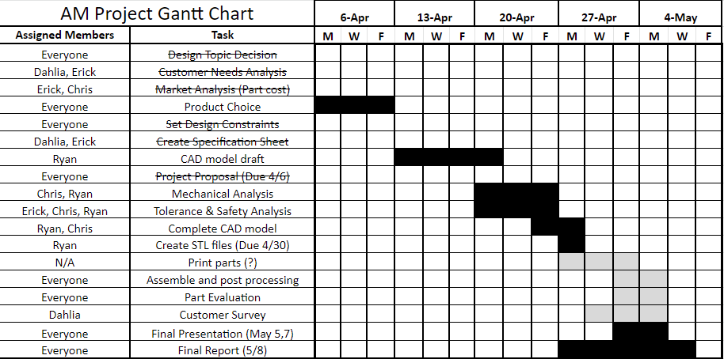

### 

### Appendix B: Customer Needs Survey Form

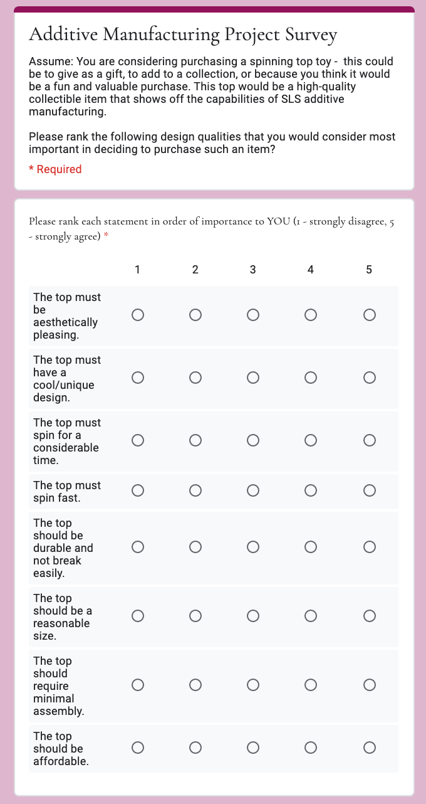

Figure B.1: Survey Form Page 1

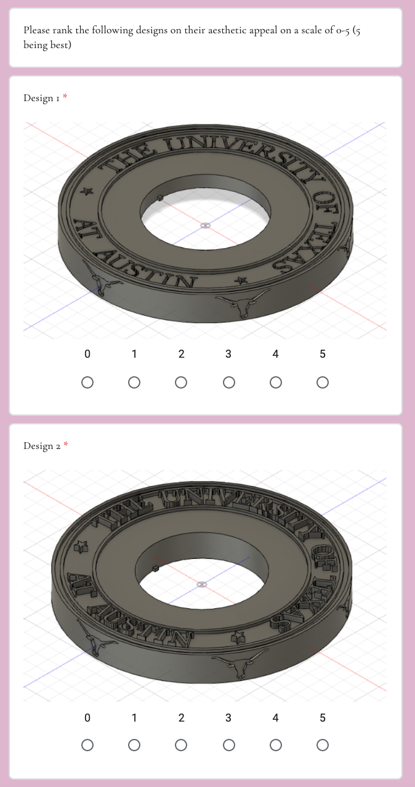

Figure B.2: Survey Form Page 2

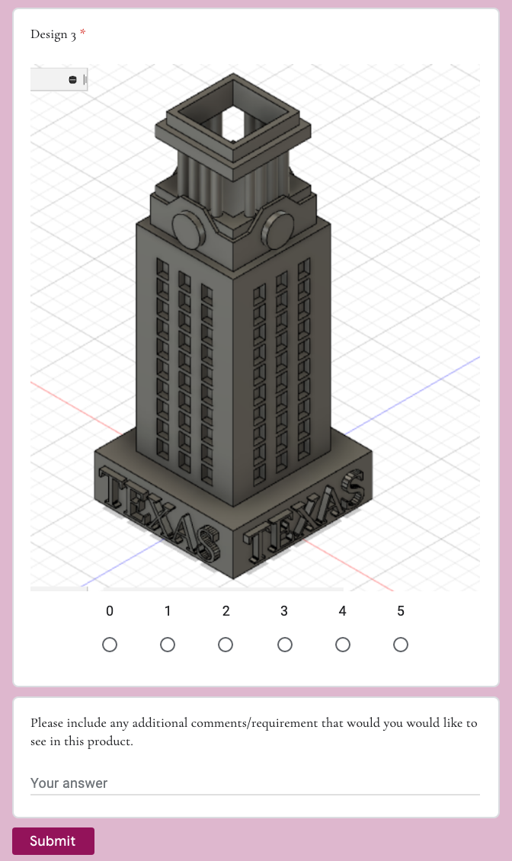

Figure B.3: Survey Form Page 3

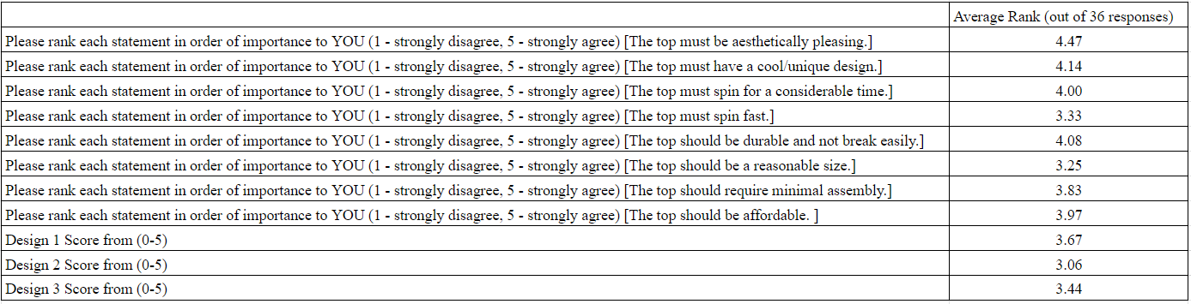

Table B.1: Average Survey Results

### Appendix C: Aerodynamic Analysis

Finding minimum RPM

The minimum spin speed (in revs per second) for a typical top to be stable is roughly equal to √g/a where g=9.81m/s2 and a is the radius of the top. ([**http://www2.eng.cam.ac.uk/~hemh1/gyroscopes/spinningtop.htm**](http://www2.eng.cam.ac.uk/~hemh1/gyroscopes/spinningtop.htm)**)**

Since we designed a top with a radius of 4cm, the minimum spin speed was around 4700rpm. The target rpm was set a little higher, around 5400rpm, to account for errors.

Approximating Incoming Velocity

Literature regarding maximum air velocity from the human lung varies, depending on the individual's gender, health, lung capacity, age, and most importantly, measurement method. A biomedical paper by Lausted et al. shows that expiratory pressure can vary from 39 cmH2O (lowest, female) to 97 cmH2O (highest, male), but the uncertainty is also significant, ranging from 25 to 44cmH2O. A value of 40 cmH2O (~3900Pa) was chosen as a conservative baseline. Using Bernoulli’s equation, a lossless velocity is computed to be 80m/s. Human lung capacity is finite, however, and the number is likely to be lower when the size of the exit area is reduced to a realistic area of a small tube or mouth as it increases pressure loss.

Second source was a design guideline for aerodart (<http://aerodart.com/Guideline.html>). There are similarities between blowing through a blowgun and blowing through a tube inside the tower, so this guideline can provide some insight. As shown in the captured screen below, a target for muzzle exit speed is around 48m/s. This is likely for a healthy male, so a number lower than this may be a good estimate.

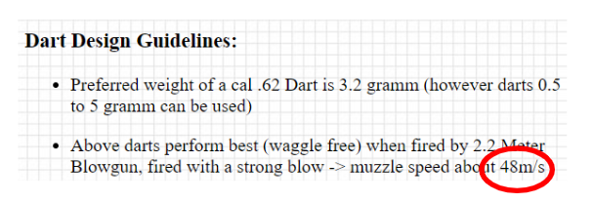

Third source came from a paper by Mhetre and Abhyankar, and part of the study uses a medical equipment called a spirometer, and found a maximum flow rate of 9.9m/s. It is unclear what the cross sectional area of the spirometer was, but it seemed to be partially blocked by an energy harvesting sensor.

Given these sources disagree widely, anywhere from 10m/s to 80m/s, we chose to go with 35m/s for inlet velocity. If the inlet velocity is lower, the leading edge of the blade won’t be effective, but the mid-chord region still has extreme curvature that will help rotating the top.

### References

Lausted CG, Johnson AT, Scott WH, Johnson MM, Coyne KM, Coursey DC. Maximum static inspiratory and expiratory pressures with different lung volumes. *Biomed Eng Online*. 2006;5:29. Published 2006 May 5. doi:10.1186/1475-925X-5-29

Design guideline for Aerodart: <http://aerodart.com/Guideline.html>

Mhetre MR, Abhyankar, HK. Human exhaled air energy harvesting with specific reference to PVDF film. *Engineering Science and Technology, an International Journal*. Feb 2017, Volume 20, Issue 1, Pages 332-339. <https://doi.org/10.1016/j.jestch.2016.06.012>

Images for various tops on the market:

<https://www.billetspin.com/maelstrom>

<https://www.shapeways.com/forum/t/tornado-spinning-top.29528/>

<https://www.shapeways.com/product/NJ4TFJV6W/functional-spinning-top?li=shareProduct>

<https://foreverspin.com/>

<https://db-tops.com/shop/the-turbine-top>